**INVENTORY MANAGEMENT SYSTEM**

For CODEX-SOLUTIONS

|  |  |
| --- | --- |
| **Title of the Project** | Web based inventory management system |
| **Batch** | Weekend |
| **Development Technology** | C#, Web API Core, MSSQL  AngularJS 2, NodeJS, jQuery, HTML, Bootstrap  WPF |

**Description of the Project:**

|  |
| --- |
| The client Codex- Solutions is a software development and IT consultancy service at Pannipitiya. Our core concern is to design a software which can be deployed at any company and can be customized to handle their Inventory as outlined by the client. This includes the functions of ensuring efficient tracking of stocks details and timely ordering, transaction management, handle inventory access, return and wastage management, offers scheduling and provide a full range of reports that will satisfy statistical requirements.  The software consists of a Web API (RESTful web service) as the central data source, client applications including a desktop application (WPF application) and a web based application (Angular 2 application). |

**Details of the Group Members:**

|  |  |  |  |  |
| --- | --- | --- | --- | --- |
|  | Name with Initials | Registration Number | Contact Number | Email |
|  | Basnayake M.C.S.B | IT16158764 | 0778511690 | chathurangabasnayake@outlook.com |
|  | Amarasinghe U.P.A.S.D | IT16160330 | 0779955111 | samithdilsh@gmail.com |
|  | Rodrigo U.S.D | IT16154490 | 0772772682 | dilee1st.1995@gmail.com |
|  | Bimali Y.M.Y. | IT16423534 | 0777668498 | b.yapabmmv@gmail.com |
|  | Rajapakshe R.W.D.K.P | IT16225916 | 0771617349 | kaveendrarajapakshe@gmail.com |
|  | H.S.K.Wijesekara | IT16130562 | 0771993040 | harinwijesekara@gmail.com |
|  | U.S.O.Vindula | IT16161566 | 0779766605 | ovinud99@gmail.com |
|  | L.L.K.S.Lokuge | IT16133914 | 0713947924 | kawee@live.co.uk |

* Our Client…
* Client’s Requirement…

Our client requests a software which can be deployed on any organization to handle their inventories. Instead of developing inventory system for each organization. Even with these requirement client side cannot be complex. It should be user friendly.

* What’s Special…

Looks like a regular inventory system, but this isn’t. This inventory system can be deployed in many type organization to handle their inventory. As an example, this inventory system can deploy for supermarket, pharmacy, electrical shop, bookshop, etc.

Also, this system is suitable for different level of organization. If organization has only single machine. This system can run on it. If Organization has branches network spread through the world, this system can handle it.

In other words, this is a partially generic software.

* Technologies…
* RESTful Web service for Backend
  + C#, ASP.NET CORE framework WEBAPI
  + MS SQL Server & Entity Framework
* Web Application for Frontend
* HTML5, CSS3, Bootstrap, jQuery
* Angular 2, NodeJS, npm package manager
* Desktop Application for Frontend
* C#, ADO.NET, XAML, WPF Applications
* SQLite Database
* Why API?
* The first reason is our client ask for it. Because they can maintain, develop, evaluate the system easily.
* With API, we only have to implement business logic once for multi-platform users.
* We can develop different types of frontend software to run this system on different platforms with less effort.
* API is more effective when multiple users accessing the central data source concurrently. And more secure.
* Web application
* Our system’s most functions can be access by web application.
* We develop web application because its **Platform Independent**.

* Desktop Application
* Our services based on internet. We can’t grantee that internet connection without any connection issue or servers without failures 24/7. But some service(s) must available no matter what happen.
  + Example, Invoice and Billing Service.
* As a solution, we are building Desktop Application with in-built Database.
* With this approach,
  + Minimize request that send to API. Because we can cache some data in local.
  + Can build Reliable Application.
* PS: This is not a Standalone Application. Application still works with Web API. But when connection down, it can work as a Standalone Application for only Invoice and Billing Service. When connection is up it syncs data back to API. And works as normal.

**System Architectures**

* Single Branch

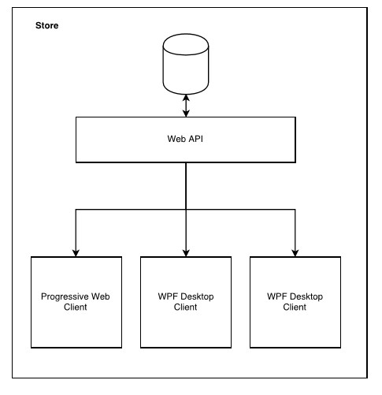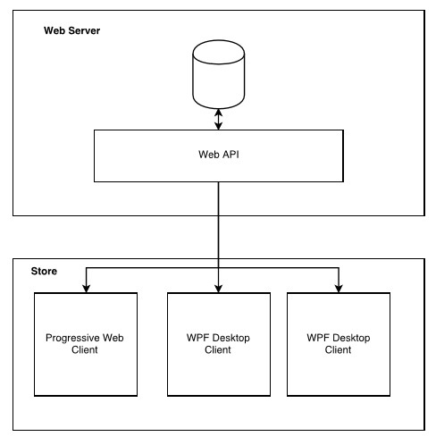

* 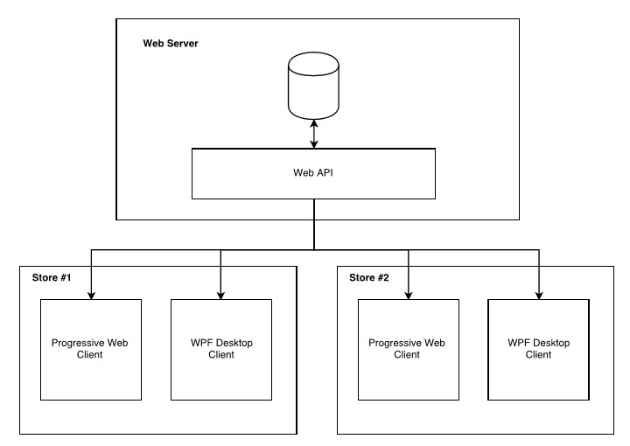Branch Network

Employee Management,

System Initializing & Authentication.

Function-In-Charge : Amarasinghe U.P.A.S.D | IT16160330

• System Initializing

• Employee Management

• User Account Management

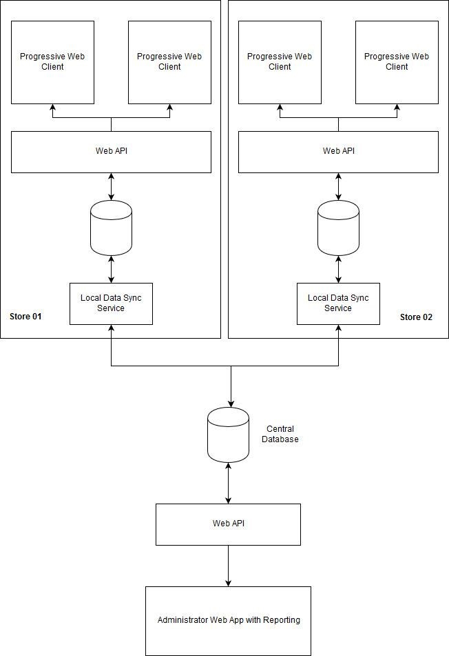

**INVENTORY MANAGEMENT SYSTEM**

* **Employee Management**

Function-In-Charge: Amarasinghe U.P.A.S.D - **IT16160330**

* System Initializing
* Employee Management
* User Account Management
* User Roles Management
* User Privileges Handling
* Branches Management
* Routes Management
* User Logs Management
* Higher Authorization Request
* Reports Generating

* System Initializing
* After deploying the system. System ask to enter core information about the company. Such as Company Name, Branch name, Logo, System admin details, etc.
* Also initializing state admin can restrict unwanted sections. If they don’t want delivery function admin can remove it.
* User Roles Management

After initializing the system. Admin should manage User roles first, It Includes,

* Adding new user roles & Viewing current user roles.
* Modifying, Suspending & Deleting user roles.
* Privileges Management

Every section has 4 different access types.

Read, Create, Update & Delete

After adding user roles admin can give/ revoke any section’s any access type to/ from any user role. Including giving/revoking access types

* Employee Management
* Next important function is employee management, which includes
* Adding new employee with personal details
* Searching employee (Simple Search / Advanced Search)
* Modifying employee details
* Suspending employee & Deleting employee
* Assigning a branch to employee
* User Account Management

After adding employees and user roles now system allows to make user accounts, which includes.

* Adding new user account, viewing new user accounts
* Suspending/Deleting user accounts
* Password resetting
* Login & authorization keys handling
* Sessions handling.
* Branches Management

Admin/User can manage branches information. Including,

* Adding new branch, Searching & viewing branch information.
* Modifying, Suspending & Deleting branch.
* Employee transferring one branch to another.
* Higher level authorization requests

Some user doesn't have some authorization. They can do the task but they need high level user’s approve to commit the task. In this case user are requesting higher level authorization. Request can be send to right user. If high level user approves the request task will commit. Otherwise it won’t work.

* User Log Management

With each of function usage, System make a log with all important details. Such as function name, date, time, username, branch, etc. This includes,

* Adding, Viewing & Searching through user logs.
* Deleting User Log (This is the only feature only system admin can use).
* Routes Management

This is how user access grant or restrict for each section. After checking authentication key and privileges route can be access or can’t be access. Sometime routes can be access but some request cannot be made.

* Reports Generating

Reports generating is most required feature in bespoke software. Above functions generate these reports

* List of employees, Specific employee complete information.
* List of branches, List of users with user roles.
* User roles with privileges list
* List of user logs after any filtering records.
* **Products Managements**

Function-In-Charge: H.S.K.Wijesekara - **IT16130562**

* Add, Update, Delete Products
* Categories & Subcategories price codes, add, update, delete & display
* Products Sections managing
* Label generating
* Products expire notifications handling.
* Reports generating
* Add, Update, Delete Products

For the products we have maintain its details,

* Adding new products details to the system.
* Changing the existing details of the products in the system
* Removing product details from the system
* Categories & Subcategories price codes, add, update, delete & display

When we are adding or updating a product system will ask what the category and sub-category of that product. Because it help to handling products. For that we have to give a way for,

* Adding new categories & subcategories details to the system.
* Changing the existing details of the categories & subcategories in the system.
* Removing categories & subcategories details from the system.

Sometime we get the same product but vary with the quality. If we try to give another product code system get more complicated. In case of that that we can’t subdivide them using a price code.

* Products Sections managing

Products section managing is to help to track product after and before we place them on store. When we get our expire notification we can track the product inside the store.

* Label generating

Some product’s price varies with weight. In that case we have to measure it and have to give a price for that measured amount. In this labeling part we have to create a label which contain both product code and its weight.

* Products expire notifications handling.

When a product is going to expire we have to notify that for someone who is in charged for that. We give this notification in advance and it’s depend on the product nature.

* Reports generating
* Report(s) with product details.
* Repost(s) with the categories & subcategories and their detail.
* Report(s) with the products sections with products which include in that section.
* **Promotion Schedules, Discounts Schedules and Management**

Member-in-charge: Rodrigo U.S.D. **| IT16154490**

Sales offers and discounts is one of the major aspects of promotional mix. In our system we are going to handle following tasks under Discounts scheduling and Management.

* Discount schedule add, update, delete & display
* Promotions schedule add, update, delete & display
* Promotion expire notification
* Gift vouchers handling
* Reports generating on the discounts and promotion schedules
* Discount schedule add, update, delete & display

Discounts can be a price deal depending on Festive season, non-cumulative quantities, trade-up credit, Educational or Student/ discipleship, Employee discount and age-related discounts. Since our concern is to create a system which is deployable in any organization, we are going to handle all the types of discounts and allowances mentioned above.

This includes,

* Add schedules
* Adding discount schedules to the system i.e., discount type, period of offering, special stocks reserved for allowances if there are any etc.
* Update schedules
* Maintaining up-to-date details about the agreed schedule, stocks
* Update the discount rates and stocks upon any changes to the schedule by authorized personnel
* Display schedules and related information
* Generate and display notifications relevant to the schedule expiration and stocks count
* Display current status of the schedule for authorized personnel
* Delete schedules
* Delete schedules related information from the system such as discount amount/rate for particular amount after it has been declared as expired
* Promotions schedule add, update, delete & display

Promotions can be price-pack or bonus pack deals, checkout dispensers and related cents-off deals, and sampling.

This task includes,

* Add schedules
* Adding promotion schedules to the system i.e., product combinations, period of offering, special stocks reserved for allowances if there are any etc.
* Update schedules
* Maintaining up-to-date details about the agreed schedule, stocks
* Update the discount rates and stocks upon any changes to the schedule by authorized personnel
* Display schedules and related information
* Generate and display notifications relevant to the schedule expiration and stocks count
* Display current status of the schedule for authorized personnel
* Delete schedules
* Delete schedules related information from the system such as product combinations after it has been declared as expired
* Gift vouchers handling

Range of gift vouchers are issued with a unique and unpredictable code ensuring neither misuses nor theft. In addition to that,

* + - * Keeping track of issued gift vouchers and quick verification upon redeeming
      * Proper cancellation once used so that redeemed gift vouchers are not brought again.
      * Updated details of offers specific for Gift vouchers
      * Facilitate providing necessary details of the gift vouchers to publish in the invoice.
* Promotion expire notification

Promotion expire notification is displayed under following circumstances

* When an offer is declared expired by the management
* When the offer is based on a particular stock and that reserved stock is over

This expiration notification also helps users to remind to delete the particular schedule details.

* Reports generating on the discounts and promotions schedule

Above mentioned functions will generate,

* + - * Reports about discounts/promotions offered on certain items and relevant statistical data such as customer insights on the product which will help the management to decide between trade-offs.
      * Reports on Gift voucher details which management can utilize to decide about issuance of them
* **Stocks Management, Return and wastage management**

Member-in-charge**:** Bimali Y.M.Y. |**IT164253534**

Stocks management is assessing the inventory by ensuring the possibility to meet the demand and prevent running out of critical materials or goods. For that the system is having following functionalities.

* Stocks add, update, delete, & display
* Trans in/out stocks handling
* Recounting stocks and rectifying
* Promotional stocks handling
* Low-stock notification

Handling inbound returns and reverse logistics efficiently can increase the value recovery and reselling of the particular item. Also, the wastage stocks should be handled properly adhering to state laws. These tasks are achieved through following functionalities.

* Products returning from customers and replacements
* Updating stocks with returning goods
* Wastage stocks handling
* Report Generating
* Stocks add, update, delete, & display

Stocks details should be updated at the time of in housing.

* Add stocks
* New stock details such as item name, quantity are added to the system at the point of in housing and assigning stock numbers along with storage details
* generating Goods Receipt Notes(GRN)
* Update Stocks
* Stock details are frequently updated following issuances, trans-ins/outs
* Delete stock details
* Delete old stock details, wastage stocks depending on the recommendation of higher management by authorized personnel
* Display current status and relevant statistical data about a particular stock or overall inventory for authorized personnel
* Trans-in / Trans-out stocks handling

This is useful for an extended organization with several branches as they can share available stocks when needed. At this point,

* Updating system with trans-in and trans-out stock details
* Issuing GRN for trans-in stocks and update the system with GRN received for trans-out stocks

will be done.

* Recounting and Rectifying

Occasional stock re-counts can ensure reliability of the data and help the management to discover any theft or misuses. Our intension is to do the recount while normal procedure is in action with special functions.

* Promotional stocks handling

Stocks details which are reserved for promotions are frequently updated while issuing it can be helpful for the stock-based promotions to declare the promotion expiration.

* Low-stock notification

A notification with stock status is generated when the predefined minimum is reached for a particular product.

* + Products returned from customers and Replacements

This can update the returned item details including product details, causes for return to decide the whether to dispose or return to the supplier and details about replacements done.

* + Updating stocks with returning goods

Stocks are updated with returning items from suppliers and replacements for trans-out stocks.

* Wastage stocks handling

Wastage stock details are updated as a separate category and simultaneously, original stock details are also updated.

* Reports generating

Above mentioned functionalities can generate following reports

* New stocks added during some time period
* Reports on Trans-in Trans-out stocks
* Promotional stock details
* Reports on recounts carried on
* Reports on Return and replacement
* Reports on Wastage stocks
* **Promotion Delivery and Shipment Management**

Member-in-charge: U.S.O.Vindula - IT16161566

* Order Delivery

Basically, the details of the item, destination, delivery time and the date are obtained by the system and then a summary of the order information is generated and displayed. Further the above summary is transformed to check whether the above order feasible.

* Availability

The order summary thus received is reviewed manually and checks whether the item is available in the stock and the requested mode of transportation is available on the requested date. Further, the most suitable branch to initiate the delivery is selected by considering the distance between the branch and the destination. Hence after considering the above-mentioned factors, if the delivery is feasible the process will proceed, else will be discarded.

* Pending Confirmation

Once the availability is identified the item will be delivered according to requested mode of transportation. Further in order to make sure the delivery was successful the destination endpoint should acknowledge the delivering branch. After receiving the so-called acknowledgement from the receiver, the delivery is marked as a successful one.

* Cost Handling

Then after receiving the acknowledgment, the cost of the delivery is calculated based on the destination, weight and the mode of transportation. The cost due to wastages are also included when calculating the cost.

* Report Generating

Further, a monthly report is generated based on the deliveries that have been during that particular month. Here it contains the total no of orders received and the number of successful deliveries and wastage amount. In addition to that, the branch which has accomplished the largest number of successful deliveries is also calculated and displayed in this report.

* **Invoice Handling**

Function-In-Charge: Basnayake M.C.S.B - **IT16158764**

* Add purchased items to Invoice
* Invoice Add and Print Bill, Edit, Delete
* Customer return items invoice handle
* Multiple payment methods for single
* Multiple Invoice holding
* Syncing local DB from Web API
* Internet connectivity checking & data source selection
* Reports generating

* Add purchased items to Invoice
* Using Barcode Reader
* Using Product ID/ Name
* Select Correct Item
* If there are products with two prices but with same barcode, cashier can select correct item that customer purchased.
* If there’s a discount to the item it should need to calculate and add to Invoice.
* Invoice Add, Edit, Delete
* Add Invoice
* Can be done by any “cashier level” authorized employee.
* After added or when adding Invoice, Bill must generate.
* Invoices can cancel before added without authorized employee.
* Change or Delete, Added Invoice
* If the employee isn’t authorized to Change or Delete Invoice. Then a notification sends to authorized employees. Then authorized employee can what to do.
* Customer return items invoice handle

When customer return item(s), customer has option to money back or buy any other item(s).

* Multiple payment methods for single payment

Example,

If customer need to pay Rs. 5000, customer can pay that

* VISA – Rs. 2000
* Loyal Points – Rs. 1000
* Cash – Rs. 3000
* Multiple Invoice holding

If customer says he/ she need more item(s) to buy. There must be an option to hold those Invoices other than cancel and re-enter everything.

* Syncing to local DB from Web API
* If we consider about invoice, there can be 100 different products/ items in a single list. That means 100 individual requests need to send to API in order to get those product’s/ item’s data. With add invoice, that become 101 requests.
* But if we download those data to local source we can minimize that to only one request. Because all product’s/ item’s data are now in local DB. Only request we need send is Adding Invoice.
* Internet connectivity checking & data source selection
* There’s another advantage with the previous method. That is **Reliability**.
* Even connection is down with API, application can continue with its own cached data.
* And Invoice details can save in locally until connection goes up.
* When Connection is up, sync data to the API.
* Reports generating
* Report(s) for Invoices made by specific cashier.
* Report(s) for Invoices of specific customer.
* Report(s) for Returned products/ items by Customers.